EXPT NO: 3 | IMPLEMENTATION OF CONVOLUTIONAL NEURAL NETWORKS (CNNs) FOR IMAGE CLASSIFICATION
DATE: 10.08.2026

PRE-LAB QUESTIONS (PROVIDE BRIEF ANSWERS TO THE FOLLOWING QUESTIONS)
1. What is a Convolutional Neural Network (CNN)?
Answer:
A Convolutional Neural Network (CNN) is a deep learning model mainly used for processing and analyzing images. It automatically learns important features such as edges, shapes, and textures through convolutional layers.

2. What are the functions of convolution and pooling layers in a CNN?
Answer:
- Convolution layer: Extracts important features from an image, such as edges, textures, and patterns using filters (kernels).
- Pooling layer: Reduces the spatial size of feature maps, which decreases computation and helps the model focus on important features.

3. Differentiate between image classification and object detection.
Answer:
Image Classification | Object Detection
Identifies the main class or category of an image. | Identifies and locates objects in an image.
Gives one or more class labels. | Gives class labels along with bounding boxes.
Example: "Cat" | Example: "Cat at this location in the image."

4. Why is image preprocessing important before training a CNN model?
Answer:
Image preprocessing improves the quality and consistency of input images before training. It may include resizing, normalization, noise removal, and data augmentation. This helps the CNN train faster, improves accuracy, and reduces overfitting.

5. What are the advantages of using benchmark datasets such as CIFAR-10 or Kaggle image datasets?
Answer:
Benchmark datasets such as CIFAR-10 and Kaggle image datasets provide ready-made and standardized data for training and testing CNN models. They help in comparing different models, evaluating performance, reducing data collection effort, and learning practical image classification techniques.

AIM
To design, implement, and evaluate a Convolutional Neural Network (CNN) for image classification using a benchmark image dataset.

SOFTWARE REQUIREMENTS
- Python
- TensorFlow/Keras or PyTorch
- Google Colab
- Matplotlib
- Kaggle Dataset (e.g., CIFAR-10, Cats vs Dogs, Intel Image Classification)

OBJECTIVES
Students will be able to:
- Understand the architecture of Convolutional Neural Networks.
- Implement a CNN model for image classification.
- Train and evaluate a CNN using a real-world image dataset.
- Visualize training and validation performance.
- Analyze the effectiveness of CNNs for image recognition tasks.

PROCEDURE
PART A: DATASET PREPARATION
- Perform the following tasks:
- Download an image dataset from Kaggle or use CIFAR-10.
- Load the dataset.
- Preprocess images by resizing and normalization.
- Split the dataset into training, validation, and testing sets.

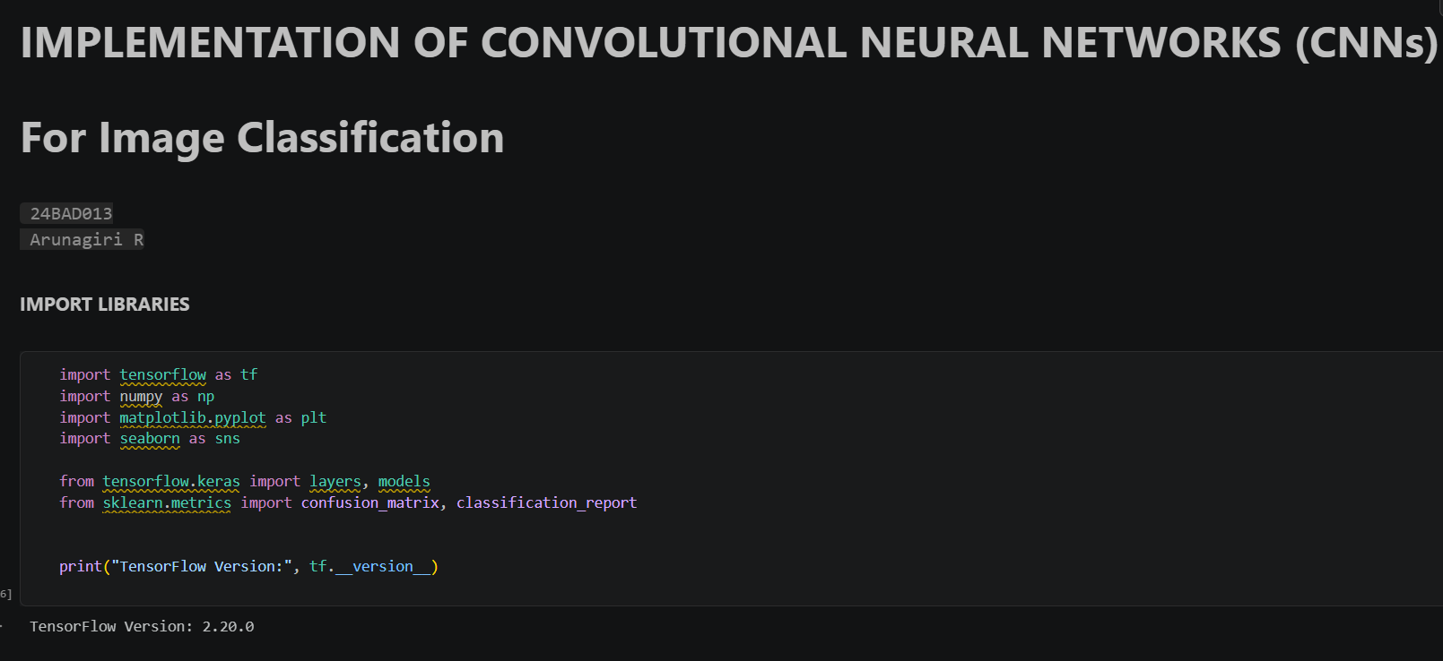

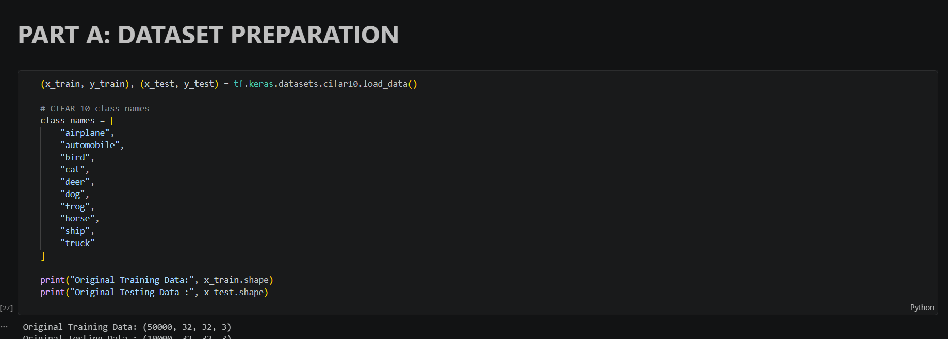

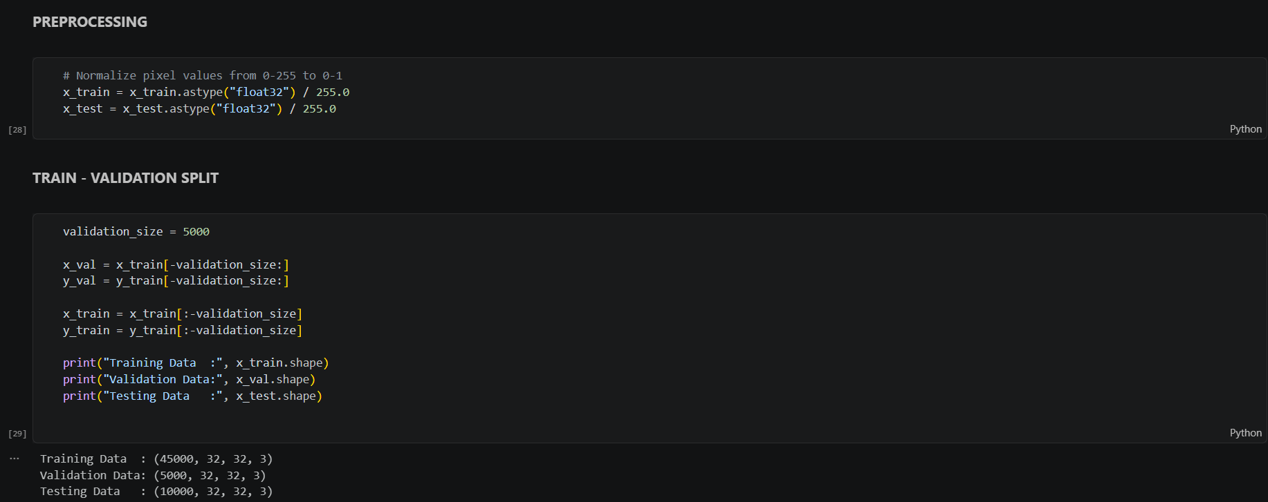
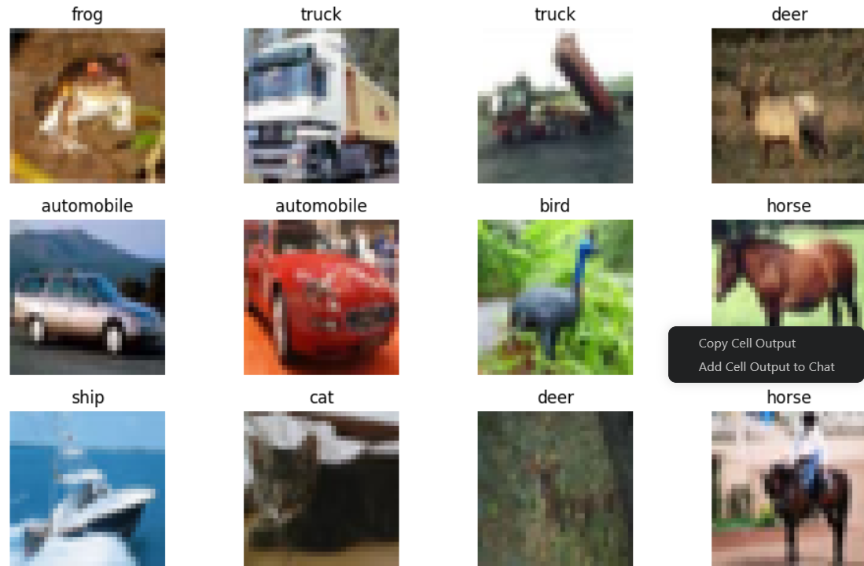
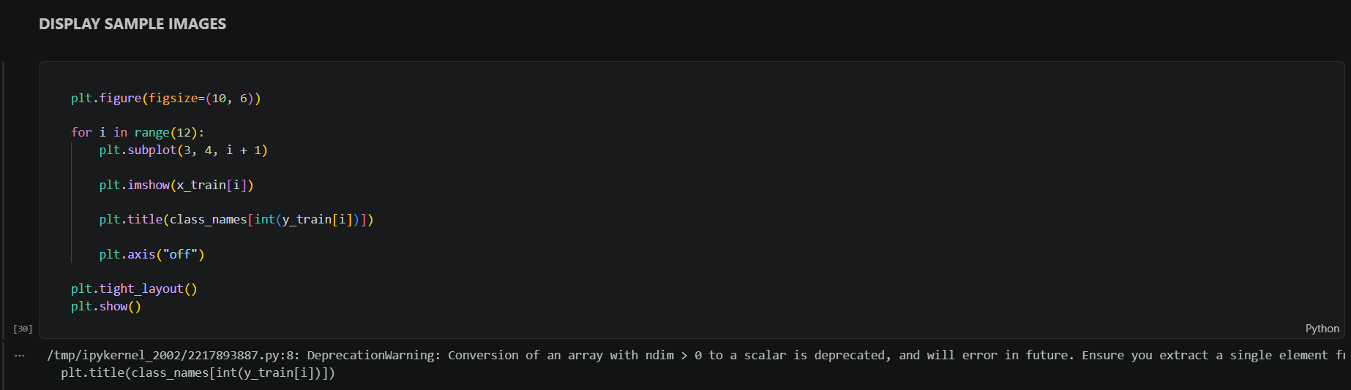

PART B: CNN MODEL IMPLEMENTATION
Build a CNN model consisting of:
- Convolution layers
- ReLU activation
- Max Pooling layers
- Fully Connected layers
- Softmax output layer

Compile the model using:
- Appropriate optimizer
- Cross-entropy loss function
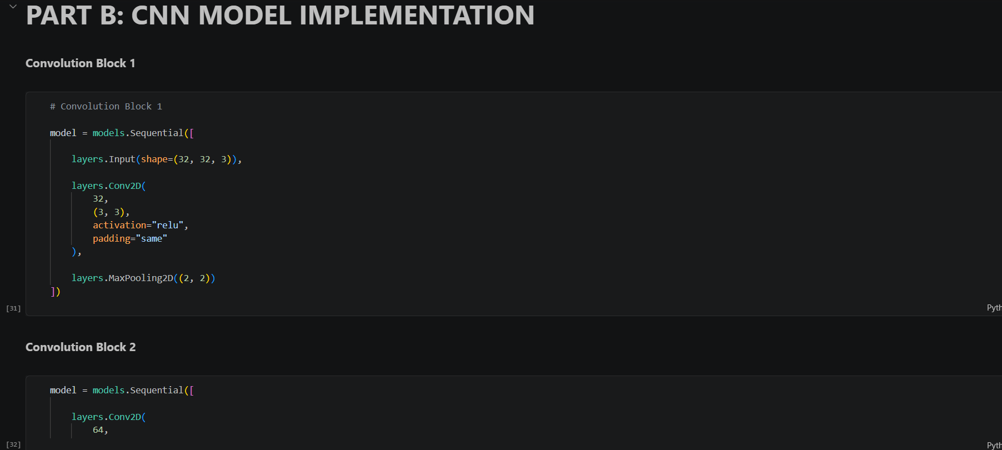

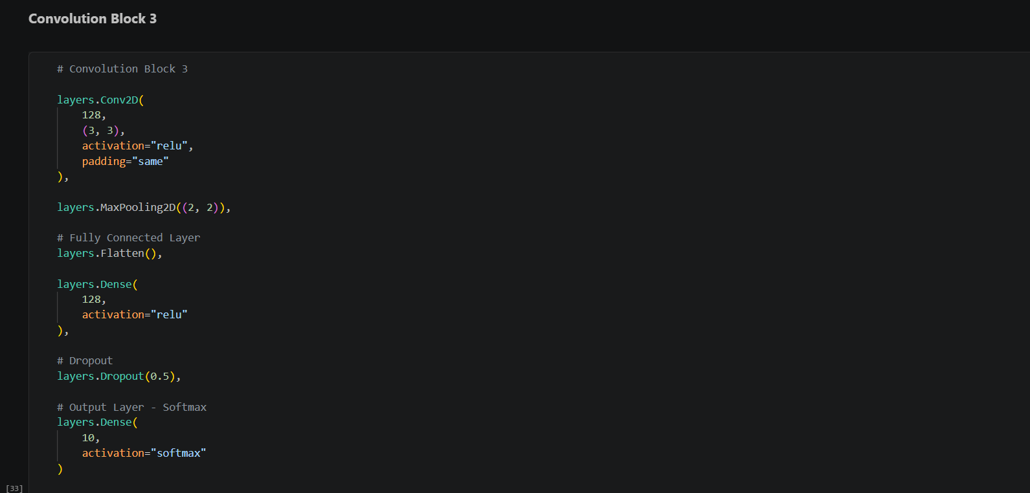
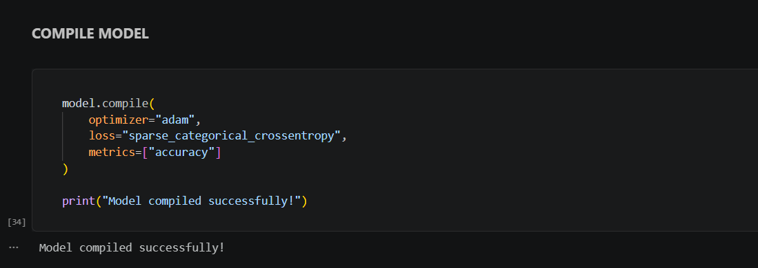
PART C: MODEL TRAINING AND EVALUATION
Train the CNN model.
Record:
- Training accuracy
- Validation accuracy
- Training loss
- Validation loss
- Testing accuracy
Plot:
- Accuracy vs Epoch
- Loss vs Epoch

PART D: PERFORMANCE ANALYSIS
Analyze:
- Classification accuracy
- Confusion Matrix
- Sample predictions
- Misclassified images
Discuss the strengths and limitations of CNNs for image classification.

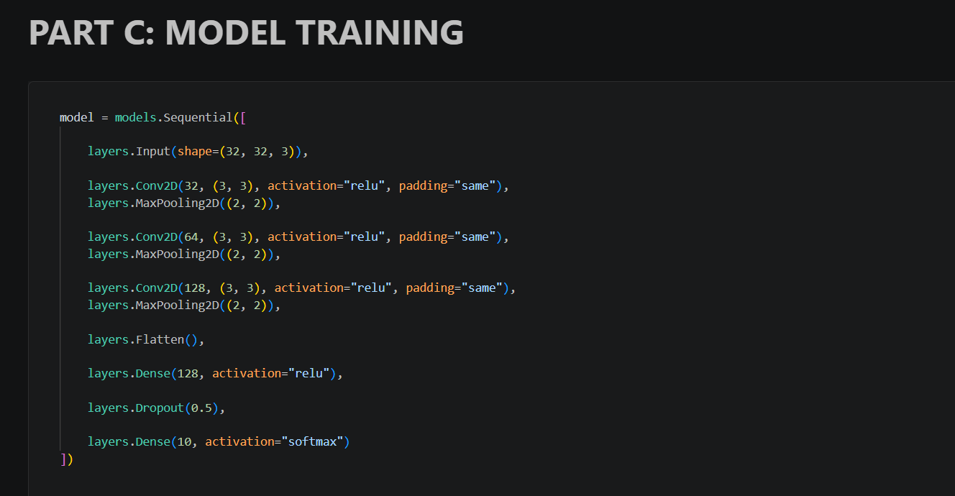

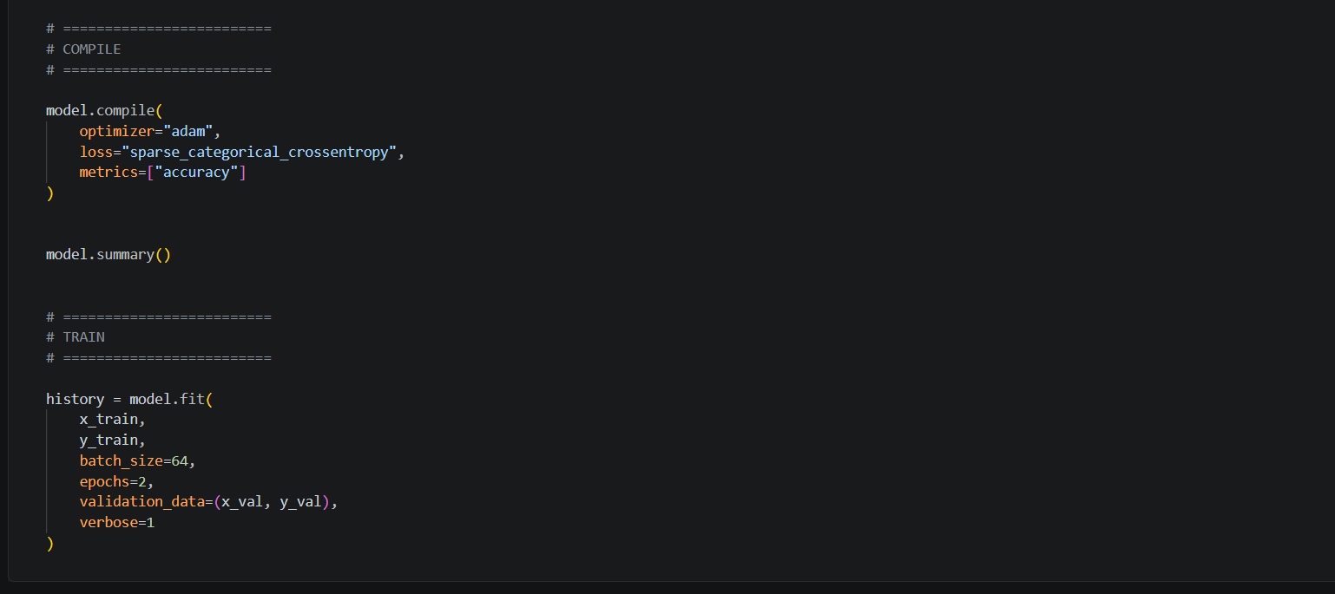

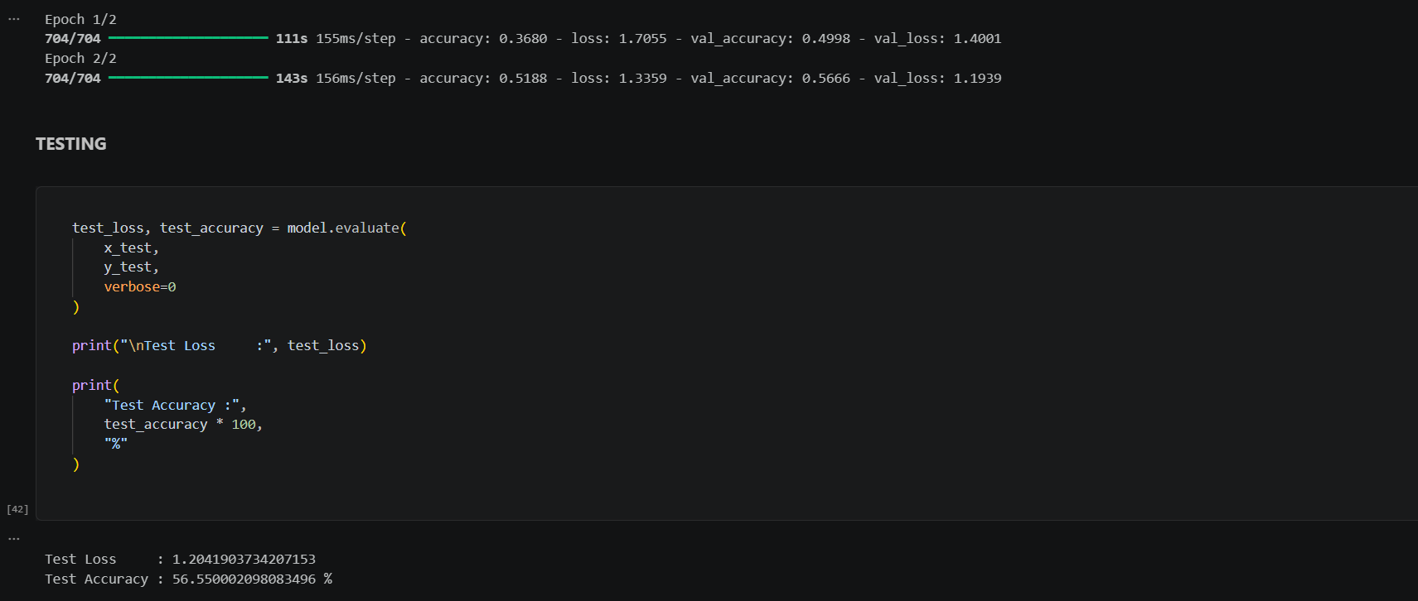

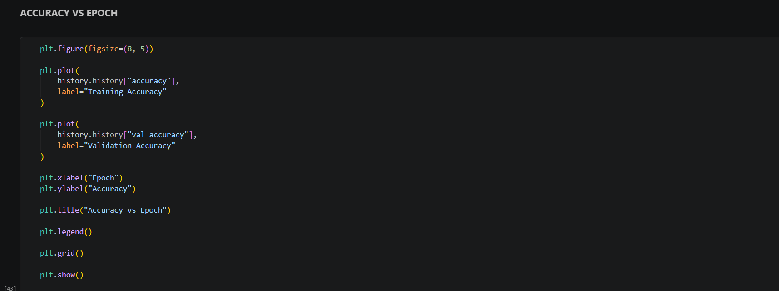
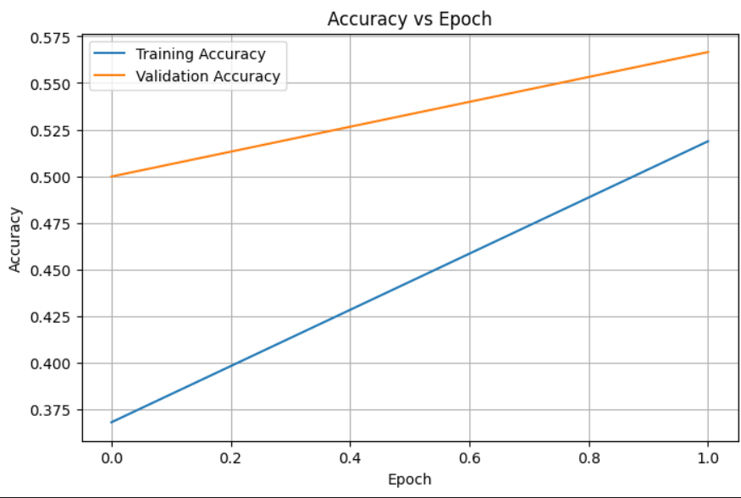

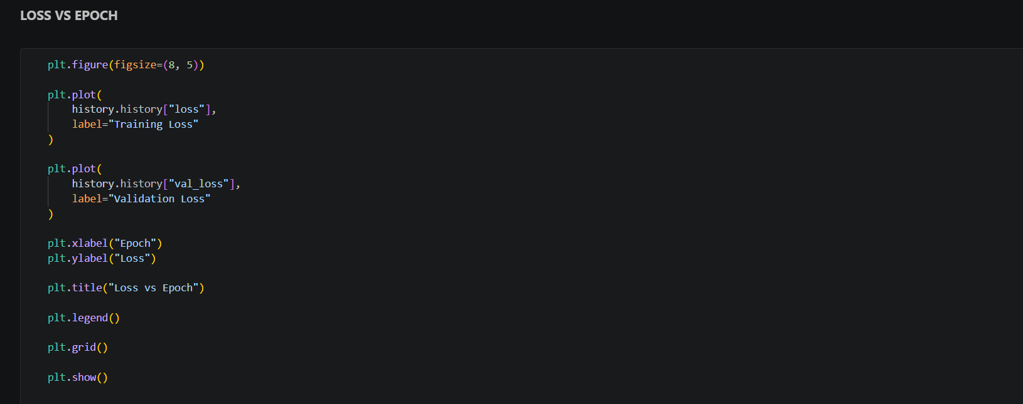
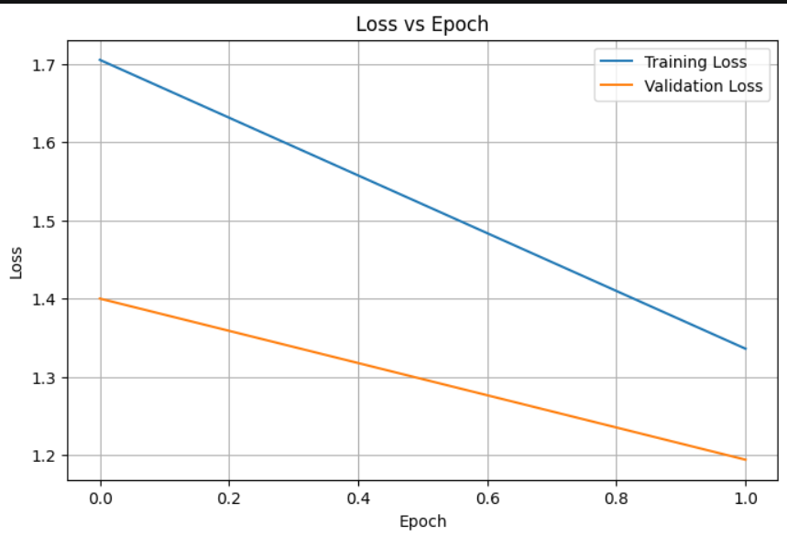

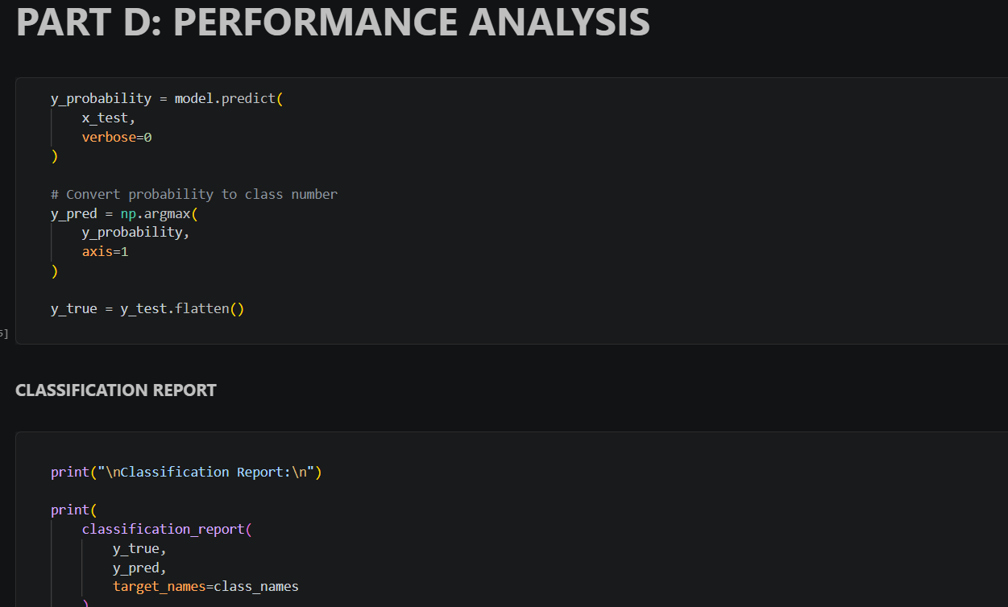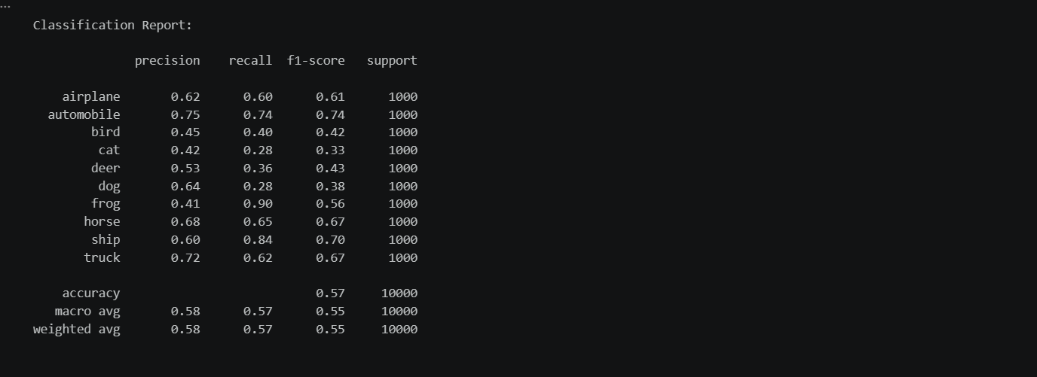

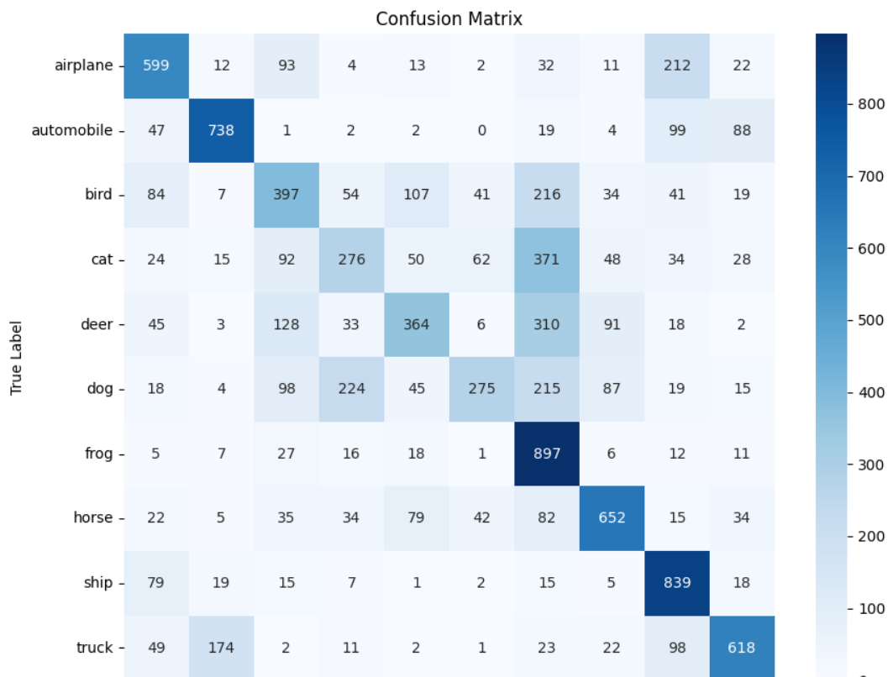

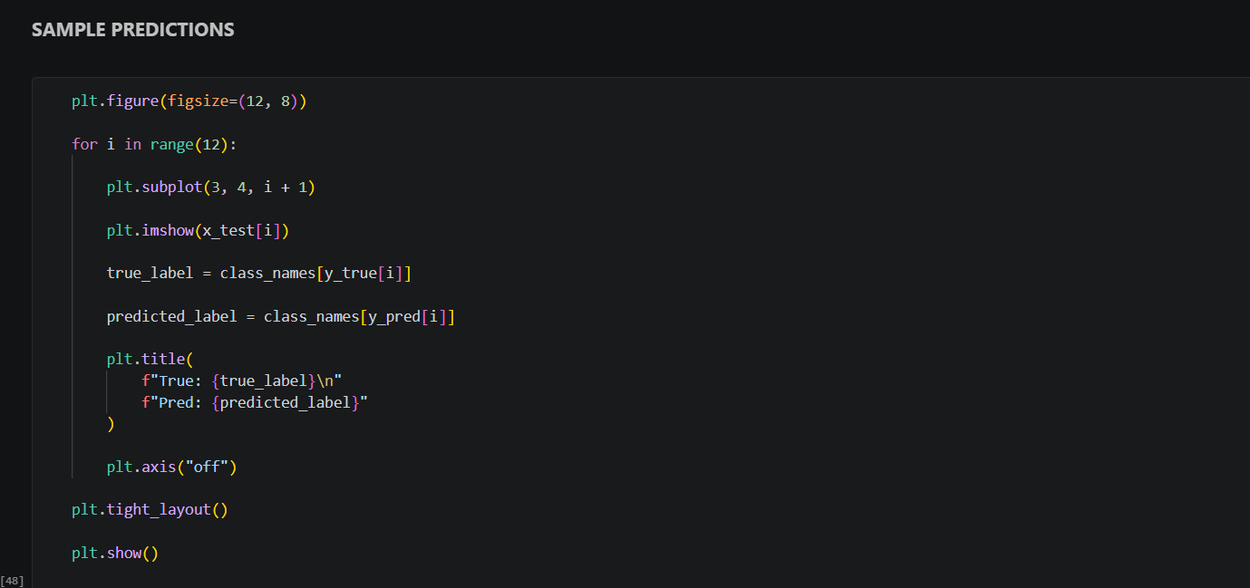

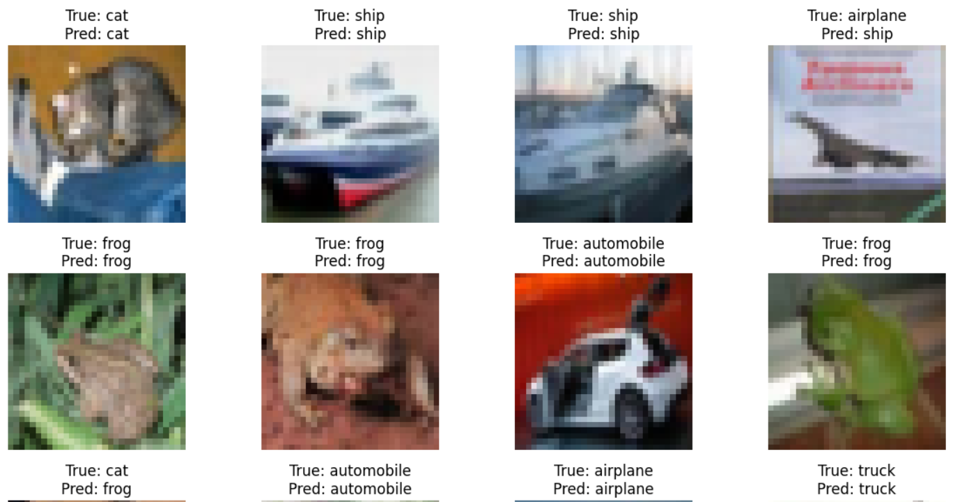

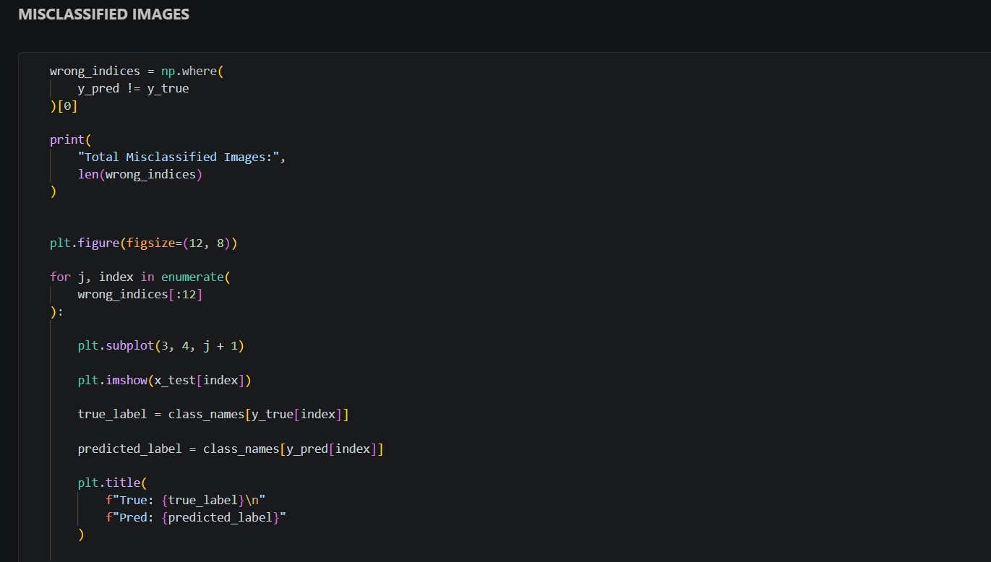

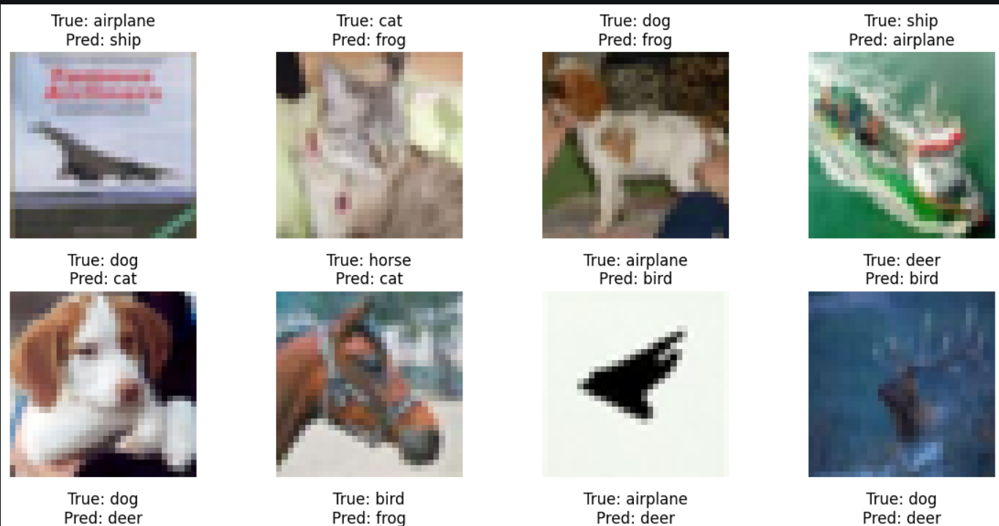

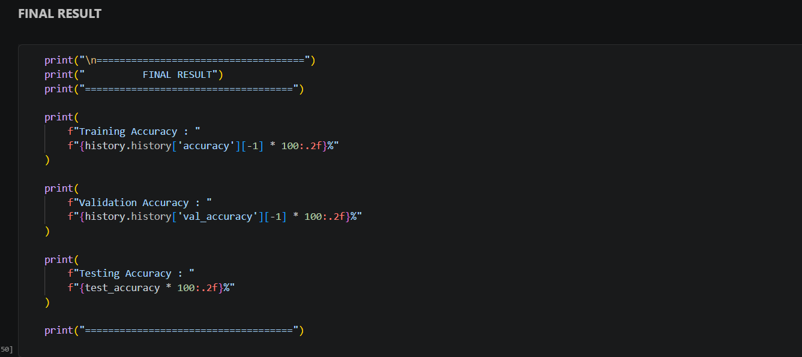

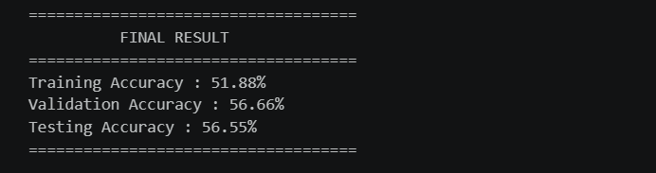

EXPECTED OUTCOME
Students will gain practical experience in designing, training, and evaluating CNN models for image classification and understand how CNN architecture influences classification performance.

POST-LAB QUESTIONS (PROVIDE BRIEF ANSWERS TO THE FOLLOWING QUESTIONS)
1. Why are convolution layers more effective than fully connected layers for image processing?

Answer: Convolution layers are more effective because they preserve the spatial relationships between pixels and detect important features such as edges, textures, and shapes. They also use shared weights, which reduces the number of parameters compared to fully connected layers.

2. How does Max Pooling improve CNN performance?

Answer: Max Pooling reduces the spatial dimensions of feature maps while retaining the most important features. This decreases computation, reduces overfitting, and makes the model more robust to small changes in the position of objects.

3. Which hyperparameters significantly affected your CNN model performance?

Answer: Important hyperparameters include the learning rate, batch size, number of convolutional filters, kernel size, number of epochs, dropout rate, and optimizer. Among these, the learning rate and number of filters can have a significant effect on training and classification accuracy.

4. What challenges did you encounter while training the CNN model?

Answer: Some challenges include overfitting, selecting suitable hyperparameters, longer training time, limited training data, and maintaining good validation accuracy. Choosing the correct learning rate and network architecture can also be challenging.

5. Suggest two improvements that can increase the classification accuracy of your CNN.
Answer: Two improvements are:
- Data augmentation – applying rotation, flipping, zooming, and shifting can increase the variety of training data.
- Hyperparameter tuning – optimizing the learning rate, batch size, number of filters, dropout rate, and number of layers can improve accuracy.

ASSESSMENT
Description | Max Marks | Marks Awarded
Pre Lab Exercise | 5
In Lab Exercise | 10
Post Lab Exercise | 5
Viva | 10
Total | 30
Faculty Signature

